Software Engineering

Department of Software Engineering

Students:
BABAR SALEEM SE-9244363

Section:
BSSE-2B-Mor

Deliverable no:
1


[COMPANY NAME] | [Company address]

Smart Learn

Smart Learn
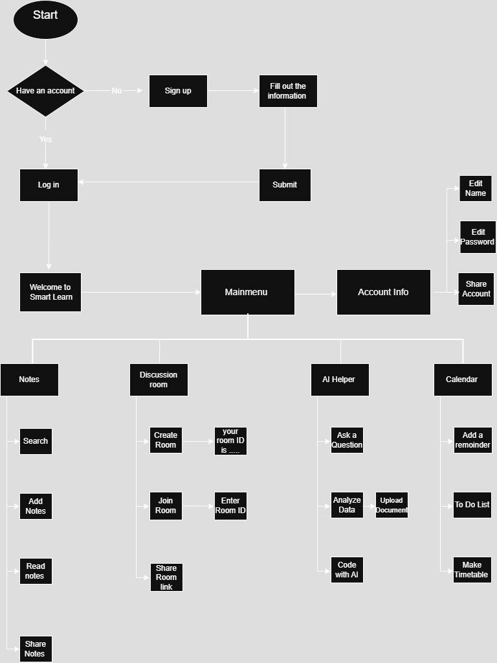

Phases

Requirements
Sharing notes and books Discussion rooms
AI helper
Deadlines reminder
Analysis
Feasibility Analysis System Constraints Module Breakdown Business Alignment

Design
System Architecture HLD s LLD
Design Documents
UI/UX s Database

Coding/Implementation
Source Code Development Design-Guided Implementation Coding Best Practices
Working Software Output

Testing
Requirement Verification Multi-level Testing
Bug Identification s Fixing Functionality Assurance
Deployment
Production Deployment Server/App Setup User Onboarding
Performance Monitoring
Maintenance
Post-Deployment Support Bug Fixes s Updates Technology Adaptation Ongoing Enhancement

